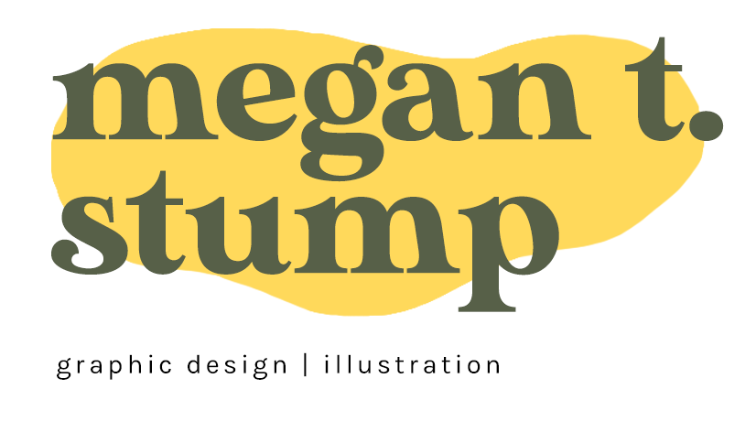

Los Angeles, CA
Passionate and versatile professional working in Graphic Design, specializing in Motion Graphics and Illustration as well. Thrives in a creative work environment and strives to bring new ideas/techniques to the table. Accustomed to working in many different media driven atmospheres including Design, Story/ Illustration, Video Production, and Social Media. Affinity working in tech-driven environments as a team or independently. Experience in leading a team of designers as well in order to meet creative goals and deadlines. Brings an upbeat & positive attitude to the workplace while staying on top of goals.
Portfolio can be found at megantstump.com
Senior Graphic Designer - Warner Bros. Discovery
Burbank CA, April 2024 - Current
Currently developing and creating unique artwork for new and returning television productions. Managing and directing a team of freelance designers as well to meet deadlines, hit target goals, and create impactful and memorable graphics. Design work has to be on trend and using the latest methods and softwares, while still fitting within the larger WBD brand guidelines and image.

Senior Graphic Designer - Motortrend Group
El Segundo CA , June 2023 - April 2024
Produced designs and high-level broadcast quality motion graphics for the MotorTrend Creative & Brand Studio. Work consisted of creation, layout, and execution of graphics for marketing promos, social videos, graphics packages, interactive content and more. Often tackled projects solo, but also worked collaboratively with a team of designers and editors to deliver on-trend designs at a fast paced delivery schedule.

Social Media + Brand Coordinator - Bento Box Entertainment,
Los Angeles CA, Aug. 2022 - June 2023
Previously worked as a social media and brand coordinator for the animation company Bento Box Entertainment. Position entails creating and posting content for all social media accounts, as well as managing and redesigning Bento Box’s website.. In addition, responsible for running the Bento newsletter, company events, and coordinating with outside advertising campaigns.

Lead Graphic Designer - Discovery Channel, Los Angeles CA, Apr. 2019 - Aug 2022
Worked as lead graphic designer/motion artist for the digital production team. Projects intended for social media as well as website streaming and live TV publishing. Collaborated mainly with a core team but also coordinated with larger teams within Discovery as a whole. Position required heavy multitasking as well as adhering to strict deadlines. Art directed and-
produced graphics for 7 episode midform series airing during Shark Week three years running. Utilized software such as Illustrator, Photoshop, After Effects and Premiere.

Graphic Designer - ResortPass, Santa Monica, CA. Oct. 2019 - March 2020
Previously worked as a graphic designer for ResortPass, an online booking platform for access to resorts and hotels for pools, spas, fitness centers, and much more. As Visual Designer at Resortpass, creative responsibilities include social media content creation and digital advertising, email marketing, brand strategy, outdoor advertising, event design, presentations, photoshoot production and photo editing, and UI web design.

Graphic Designer – Lava Surf Orem, UT 7/2017-4/2019
Previously worked full time as remote graphic designer for a social media management company in Orem, UT. Created innovative, on trend, and engaging graphics for client’s social sites such as Facebook, Instagram, Linkedin, etc. Also creates GIFs and animations. Use of the entire Adobe Suite on a daily basis. Worked with the team to strategize and plan out marketing and ad campaigns.

Graphic Artist – The Print Game Lehi, UT 8/2015-7/2016
Worked full time as graphic artist at screen-printing company in Lehi, UT. Work included creating logos + design materials to be printed onto shirts, banners, etc. Consulted with companies to ensure correct designs/colors, etc. for their products. Also light office manager duties such as scheduling meetings, shipping and receiving, and keeping production on schedule.

References provided upon request.
